

National University of Computer & Emerging Sciences, Karachi Department of Computer Sciences
Quiz-2(Spring-2024)

Course No: | Course Name: Object Oriented Programming
Instructor Name :M.Minhal Raza
Student Roll No: | Section: BSE-2A

"If there is something, you don’t know today. You will surely learn afterwards. Life is not an exam hall."

BEST OF LUCK!
Time Allowed: 25 minutes. Total Marks: 100
Instructions:
- Your Student ID must be written on the paper.

Question # 1:

You are hired as a software engineer to automate the Retail store system. (50-Marks)

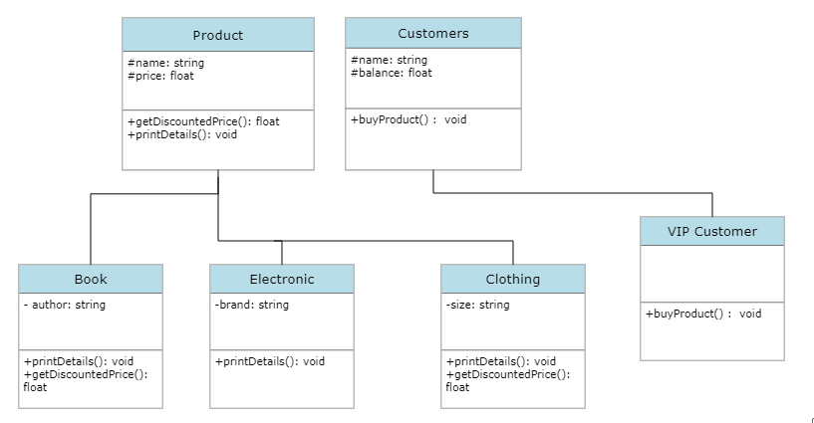
In this system, there is a base class `Product` for all the products in the store. This class has two data members: `name` and `price`, and two virtual functions: `getDiscountedPrice()` and `printDetails()`. The `getDiscountedPrice()` function returns the discounted price of the product, and the `printDetails()` function prints the details of the product.

There are three derived classes: `Book`, `Electronic`, and `Clothing`. These classes inherit from the `Product` class and add some additional data members and functions. The `Book` class has an additional data member `author` and overrides the `printDetails()` function to include the author's name

.

The `Electronic` class has an additional data member `brand`. The `Clothing` class has an additional data member `size` and overrides the `getDiscountedPrice()` function to provide different discounts for clothing items.
There is another a base class `Customer` for all the customers in the store. This class has two data members: `name` and `balance`, and a function `buyProduct()` that allows the customer to buy a product. The name variable must take your roll number as a value. The `buyProduct()` function takes a instance variable to a `Product` object and uses the `getDiscountedPrice()` function of the product to calculate the discounted price. If the customer has enough balance, the function deducts the discounted price from the balance and prints a message saying that the customer has bought the product. If the customer does not have enough balance, the function prints a message saying that the customer cannot buy the product.

We have also defined a derived class `VIPCustomer` that inherits from the `Customer` class and adds no additional data members but overrides the `buyProduct()` function to provide additional discounts for VIP customers.

Finally, in the `main()` function, we have created some products and customers and tested the program by allowing customers to buy products and printing relevant details.

// Product class
class Product {
protected String name;
protected double price;

public Product(String name, double price) {
this.name = name;
this.price = price;
}

public double getDiscountedPrice() {
return price;
}

public void printDetails() {
System.out.println("Name: " + name);
System.out.println("Price: " + price);
}
}

// Book class
class Book extends Product {
private String author;

public Book(String name, double price, String author) {
super(name, price);
this.author = author;
}

@Override
public void printDetails() {
super.printDetails();
System.out.println("Author: " + author);
}
}

// Electronic class
class Electronic extends Product {
private String brand;

public Electronic(String name, double price, String brand) {
super(name, price);
this.brand = brand;
}
}

// Clothing class
class Clothing extends Product {
private String size;

public Clothing(String name, double price, String size) {
super(name, price);
this.size = size;
}

@Override
public double getDiscountedPrice() {
// Apply a 10% discount for clothing items
return price * 0.9;
}
}

// Customer class
class Customer {
protected String name;
protected double balance;

public Customer(String name, double balance) {
this.name = name;
this.balance = balance;
}

public void buyProduct(Product product) {
double discountedPrice = product.getDiscountedPrice();
if (balance >= discountedPrice) {
balance -= discountedPrice;
System.out.println(name + " has bought " + product.name + ".");
} else {
System.out.println(name + " cannot buy " + product.name + " due to insufficient balance.");
}
}
}

// VIPCustomer class
class VIPCustomer extends Customer {
public VIPCustomer(String name, double balance) {
super(name, balance);
}

@Override
public void buyProduct(Product product) {
double discountedPrice = product.getDiscountedPrice() * 0.9; // Additional 10% discount for VIP customers
if (balance >= discountedPrice) {
balance -= discountedPrice;
System.out.println(name + " (VIP) has bought " + product.name + ".");
} else {
System.out.println(name + " (VIP) cannot buy " + product.name + " due to insufficient balance.");
}
}
}

// Main class
public class Main {
public static void main(String[] args) {
// Create products
Book book = new Book("Java Programming", 50.0, "John Doe");
Electronic electronic = new Electronic("Smartphone", 500.0, "Samsung");
Clothing clothing = new Clothing("T-Shirt", 20.0, "M");

// Create customers
Customer customer1 = new Customer("Customer1", 100.0);
VIPCustomer vipCustomer = new VIPCustomer("VIPCustomer", 200.0);

// Test buying products
customer1.buyProduct(book);
customer1.buyProduct(clothing);

vipCustomer.buyProduct(book);
vipCustomer.buyProduct(electronic);
}
}

Question-2

We want to calculate the total marks of each student of a class in Physics,Chemistry and Mathematics
and the average marks of the class. The number of students in the class are entered by the user. Create a class named Marks with data members for roll number, name and marks. Create three other classes inheriting the Marks class, namely Physics, Chemistry and Mathematics, which are used to define marks in individual subject of each student. Roll number of each student will be generated automatically.

import java.util.Scanner;

// Marks class
class Marks {
protected int rollNumber;
protected String name;
protected int physicsMarks;
protected int chemistryMarks;
protected int mathematicsMarks;

private static int nextRollNumber = 1;

public Marks(String name, int physicsMarks, int chemistryMarks, int mathematicsMarks) {
this.rollNumber = nextRollNumber++;
this.name = name;
this.physicsMarks = physicsMarks;
this.chemistryMarks = chemistryMarks;
this.mathematicsMarks = mathematicsMarks;
}

public int getTotalMarks() {
return physicsMarks + chemistryMarks + mathematicsMarks;
}
}

// Physics class inheriting Marks
class Physics extends Marks {
public Physics(String name, int physicsMarks) {
super(name, physicsMarks, 0, 0);
}
}

// Chemistry class inheriting Marks
class Chemistry extends Marks {
public Chemistry(String name, int chemistryMarks) {
super(name, 0, chemistryMarks, 0);
}
}

// Mathematics class inheriting Marks
class Mathematics extends Marks {
public Mathematics(String name, int mathematicsMarks) {
super(name, 0, 0, mathematicsMarks);
}
}

// Class to handle student data and calculate averages
class ClassData {
private Marks[] students;

public ClassData(int numStudents) {
students = new Marks[numStudents];
}

public void addStudent(Marks student, int index) {
students[index] = student;
}

public void displayStudentMarks() {
for (Marks student : students) {
System.out.println("Roll Number: " + student.rollNumber);
System.out.println("Name: " + student.name);
System.out.println("Physics Marks: " + student.physicsMarks);
System.out.println("Chemistry Marks: " + student.chemistryMarks);
System.out.println("Mathematics Marks: " + student.mathematicsMarks);
System.out.println("Total Marks: " + student.getTotalMarks());
System.out.println();
}
}

public void displayClassAverage() {
int totalMarks = 0;
for (Marks student : students) {
totalMarks += student.getTotalMarks();
}
double classAverage = (double) totalMarks / students.length;
System.out.println("Class Average Marks: " + classAverage);
}
}
// Main class
public class Main {
public static void main(String[] args) {
Scanner scanner = new Scanner(System.in);

System.out.print("Enter the number of students in the class: ");
int numStudents = scanner.nextInt();
scanner.nextLine(); // Consume newline

ClassData classData = new ClassData(numStudents);

for (int i = 0; i < numStudents; i++) {
System.out.println("Enter details for student " + (i + 1) + ":");
System.out.print("Name: ");
String name = scanner.nextLine();
System.out.print("Physics Marks: ");
int physicsMarks = scanner.nextInt();
System.out.print("Chemistry Marks: ");
int chemistryMarks = scanner.nextInt();
System.out.print("Mathematics Marks: ");
int mathematicsMarks = scanner.nextInt();

Physics physics = new Physics(name, physicsMarks);
Chemistry chemistry = new Chemistry(name, chemistryMarks);
Mathematics mathematics = new Mathematics(name, mathematicsMarks);

classData.addStudent(physics, i);
classData.addStudent(chemistry, i);
classData.addStudent(mathematics, i);

scanner.nextLine(); // Consume newline
}

System.out.println("Student Marks:");
classData.displayStudentMarks();
System.out.println("Class Average:");
classData.displayClassAverage();

scanner.close();
}
}

“OR”

Make a class named Fruit with a data member to calculate the number of fruits in a basket. Create two
other class named Apples and Mangoes to calculate the number of apples and mangoes in the basket.
Print the number of fruits of each type and the total number of fruits in the basket.

// Fruit class
class Fruit {
protected int count;

public Fruit(int count) {
this.count = count;
}

public int getCount() {
return count;
}
}

// Apples class
class Apples extends Fruit {
public Apples(int count) {
super(count);
}
}

// Mangoes class
class Mangoes extends Fruit {
public Mangoes(int count) {
super(count);
}
}

// Basket class
class Basket {
private Apples apples;
private Mangoes mangoes;

public Basket(Apples apples, Mangoes mangoes) {
this.apples = apples;
this.mangoes = mangoes;
}

public void displayBasketContents() {
int totalFruits = apples.getCount() + mangoes.getCount();
System.out.println("Number of Apples: " + apples.getCount());
System.out.println("Number of Mangoes: " + mangoes.getCount());
System.out.println("Total number of fruits in the basket: " + totalFruits);
}
}

// Main class
public class Main {
public static void main(String[] args) {
Apples apples = new Apples(5); // 5 apples
Mangoes mangoes = new Mangoes(3); // 3 mangoes

Basket basket = new Basket(apples, mangoes);
basket.displayBasketContents();
}
}

